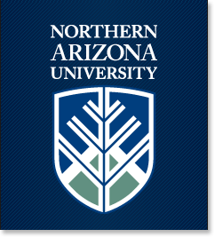

NAU news Thursday, Apr. 14, 2016

Search

- Home
- Research & Academics
- Campus & Community
- Happenings
- Faculty & Staff
- Blogs

Park ranger training opens path to career fulfillment
April 13, 20160 Comments
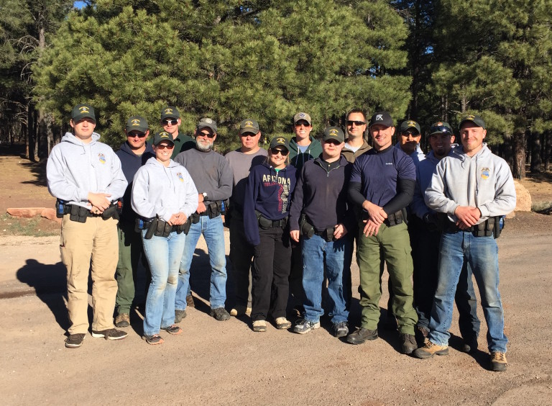
The draw of the great outdoors can be strong enough to inspire a longing for a meaningful career. For someone just starting out or answering a mid-life calling, park ranger training provides the opportunity.
Northern Arizona University is home to anationally accredited park ranger training program–one of only seven that exist in the United States—offered to anyone interested in pursuing a career protecting and serving our national parks.
“Our students come from all over the country from many different backgrounds, but they have one thing in common: a life-long love for the outdoors and a desire to protect and serve,” said Mark Maciha, a 27-year
Brie Vollmer approaching a simulated “officer down” and armed suspect condition.
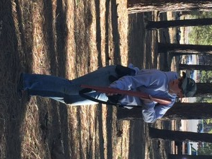
park ranger veteran and director of the Park Ranger Training Program. “Since heading up the program five years ago, I’ve seen it evolve quite a bit. Many of our current enrollees are starting second careers with backgrounds in military, law enforcement and fire service.”
Since 1998, more than 750 students have completed the semester-long NAU ranger program that consists of both indoor instruction and outdoor training exercises. Future park rangers learn how to investigate crimes, drive safely during car chases and traverse the mountain terrain, among other skills needed to protect the safety of public park goers.
A major take-away from the program involves learning first-hand, from experienced instructors, the harsh realities of law enforcement work within the park system.
“I enrolled in this program, at age 26, eager to start a second career that balances public safety with my love for the outdoors,” said Brie Vollmer, current park ranger trainee and former NAU business graduate and entrepreneur. “The NAU ranger program is very highly recommended by national park rangers and from what I’ve experienced over the past semester, I can see why.”
Maciha said participants test their newly learned skills outdoors through simulation drills, which makes up roughly two-thirds of the program. When not role playing, ranger trainees spend time in the classroom and the gym. Physical fitness is mandatory and an important part of the training.
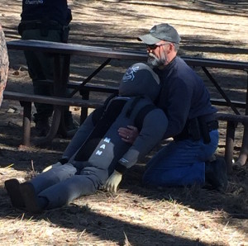
The program is offered to 26 students, twice a year during fall and spring semesters. Students may receive college credit or, for those with undergraduate degrees, a non-credit option is available.
Greg Galloway, a former 35-year medical industry executive, heard the calling to pursue a law enforcement job in the park service for some time, but didn’t actively take steps until six years ago.

Greg Galloway in a simulated rescue of an injured officer.
“I asked myself, while sitting on Point Sublime at the Grand Canyon, if I was truly doing what I wanted to do with my life and the answer was no,” Galloway said. “I met with Mark and he outlined a plan, which included pursuing a master’s degree in Park and Resource Management and participating in the park ranger training program. I’m proud to say, in my mid-50s, I now have a new career I’m passionate about as a law enforcement ranger at Glen Canyon National Recreation Area.”

